

**EE500**

**SUMMER PRACTICE REPORT**

**TUBITAK DEFENSE INDUSTRIES and DEVELOPMENT INSTITUTE**

**DIGITAL ELECTRONICS UNIT**

18.06.2018-13.07.2018

Name & Surname: Fatih Maden

ID: 2094316

Name & Surname of the Supervisor: Mehdi DUMAN

Mail: [mduman@tubitak.gov.tr](mailto:mduman@tubitak.gov.tr)

**TABLE OF CONTENTS**

HISTORY OF THE TUBITAK DEFENSE INDUSTRIES RESEARCH and DEVELOPMENT INSTITUTE (SAGE) 3

1. GENERAL DESCRIPTION OF TUBITAK SAGE 3

2. PRODUCTS AND PROJECTS 6

2.1 PRECISION GUIDANCE KIT (HGK) 6

2.2 WING ASSISTED GUIDENCE KIT (KGK) 6

2.3 STAND OFF MISSILE (SOM) 6

2.4 PENETRATOR BOMB 7

2.5 TOROS ARTILLERY ROCKET SYSTEM 7

2.6 THERMAL BATTERY 8

3. INTRODUCTION 9

4. THE WORK CONDUCTED AT THE SUMMER PRACTICE 9

4.1 FIELD PROGRAMMING GATE ARRAY 9

4.2 NIOS II PROCESSOR SYSTEM AND CORE 11

4.3 AVALON BUS STRUCTURE 15

4.4 SOPC BUILDER (Qsys tool) 18

4.3 TEMPARATURE SENSOR 21

4.4 COMMUNICATION BETWEEN ENERGY ANALYZER and PLC 24

4.5 DRIVING INDUCTION MOTOR 26

4.6 PID CONTROL VIA THE PLC 28

4.7 SINGLE PHASE SCHEMATIC 36

5. CONCLUSION 38

6. REFERENCES 39

6. REFERENCES................................................................................. 26

# 

# HISTORY OF THE TUBITAK DEFENSE INDUSTRIES RESEARCH and DEVELOPMENT INSTITUTE (SAGE)

TUBITAK SAGE established in 1972 in the name of Guided Vehicles Technology and Measurement Center (GATOM) in Besevler, ANKARA and is a served until 1983. The name was changed to the Ballistic Research Institute (BAE) in 1983. Finally, in 1988, it received the name of the Defense Industry Research and Development Institute (SAGE) and started to operate with its current structure at Lalahan Site which is 30 km away from the city center of ANKARA. [1]

Since its establishment in 1972, TUBITAK Defense Industries Research and Development Institute-SAGE performs its operations in Lalahan Site that is 30 km away from the city center of Ankara. The Center aims at meeting the requirements which was determined by Turkish Armed Forces and national defense industry organization. The institute is a part of TUBITAK – The Scientific and Technological Research Council of Turkey and specializes in the field of defense industry.

The main function of SAGE institute is to perform research and development activities for defense systems including engineering and prototype production, starting with their fundamental research and conceptual design [2]. Most of the projects are performed in coordination with other Turkish defense industry companies such as ASELSAN, TAI and other TUBITAK institutes. In the beginning of institute history, SAGE only performs research and there are no products which were produced by TUBITAK SAGE. However, nowadays the institute also produce missiles and missiles control systems besides research about defense systems.

The mission of the institute is to provide and value-added technology, product and services through R&D to defense industry. Its vision is to make Turkey independent in Defense Technologies. [3]

The institute aims to lead the development of missiles technologies domestically in parallel with Turkey’s development goals for 2023 and to develop projects for these goals.

# GENERAL DESCRIPTION OF TUBITAK SAGE

TUBITAK SAGE that is placed mainly in Lalahan/Ankara contains three main department that are Administrative Department (Institute Deputy Manager), Technology Development and Design and Management System Department. Figure 2.1 shows groups under these departments and units under these groups.

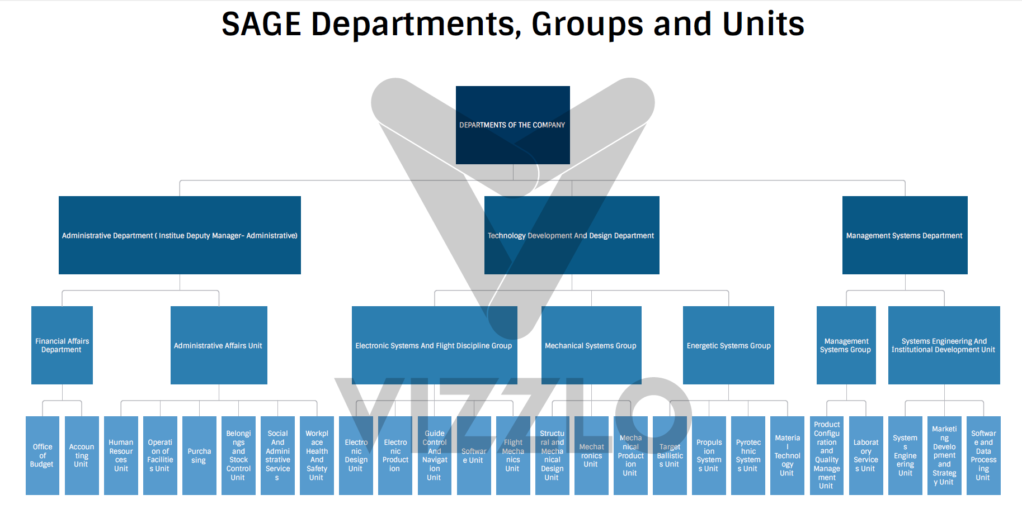

Figure 1.1 Department, Groups and Units of the institute

After departments, groups and units of the departments were introduced, organization schematic of the institute is shown in Figure 1.2.

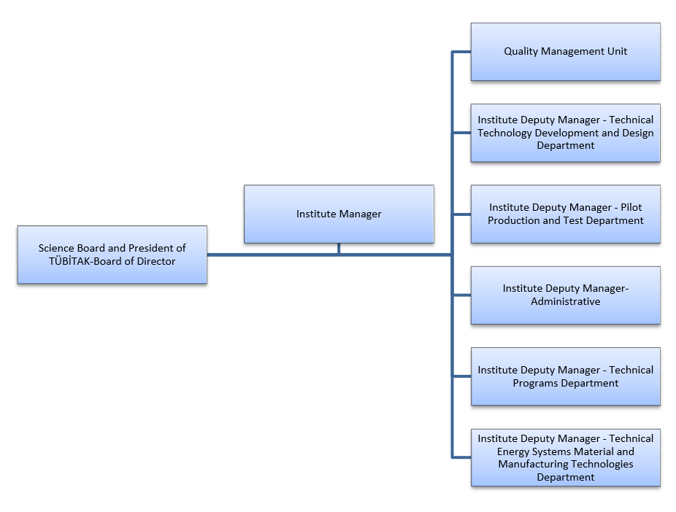

Figure 1.2 Organization chart of Tubitak SAGE [4]

Moreover, the institute is a research and development company that specialized in missile field. According to data which is obtained from human source of the institute, there are 690 workers and approximately 64% of workers is engineer in the institute. Unfortunately, human source does not share further information about personnel profile of the institute because of the confidentiality of the institute. Therefore, I could not get information about education level of personnel such as Ph.D., M.Sc. etc. On the other hand, according to my supervisor Mr. Duman a vast majority of the engineers are graduated from mechanical engineering department and electrical and electronics engineering department.

I get opportunity to work under electronic systems and flight discipline group on SAGE. I worked with Mr. Duman who is a member of electronic production unit that is a branch of electronic systems and flight discipline group along summer practice. Mr. Duman took master’s degree from METU and he is one of the project researcher of digital electronic unit.

# PRODUCTS AND PROJECTS

## PRECISION GUIDANCE KIT (HGK)

HGK is the state of the art GPS/INS guidance kit that converts existing 2000-lb MK-84 that is an American general-purpose bomb into smart weapons. It can strike a target with high precision by helping of integrated GPS/INS support. This kit can work properly for all weather condition. Moreover, HGK can reach rangers over 12 nautical miles when released from medium altitudes. A maximum range of 15 nautical miles is achieved upon releases from high altitudes.

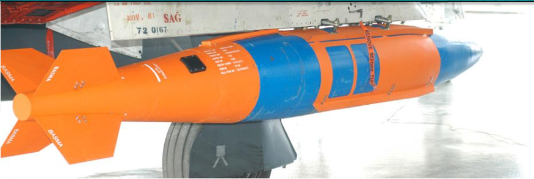

Figure 2.1 Precision Guidance Kit (HGK)

## WING ASSISTED GUIDENCE KIT (KGK)

KGK is a wing-assisted guidance kit that converts existing unguided 1000 lb MK-83 and 500 lb MK-82 general purpose bombs into long-range, air-to-ground smart weapons. With KGK, the bombs have the capability of precision hitting of the target from 100 km range, in all weather conditions, providing aircraft to complete the mission safely without entering into enemy air defences.[3]

KGK a wing-assisted guidance kit will be introduced between 07-10 May 2013 11. International Defence Industry Fair (IDEF), Beylikdüzü, İstanbul.[4]

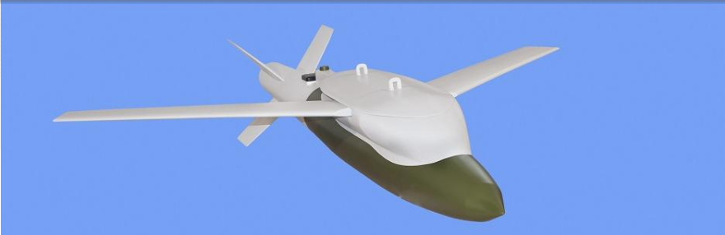

Figure 2.2 Wing Assisted Guidance Kit (KGK)

## STAND OFF MISSILE (SOM)

The stand-off Missile is an air to Surface Missile Family, designed to operate in hostile environments and to be used against heavily defended high value land and sea surface targets [5]. SOM can be launched from land, sea and air platforms. Moreover, SOM has higher precision level and higher price with respect to HGK or KGK. Therefore, SOM is only used to strike critical target.

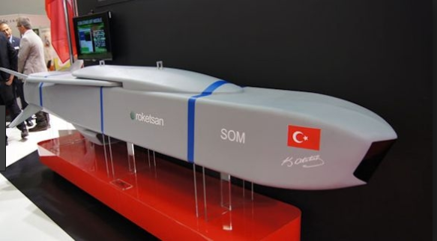

Figure 2.3 Stand off Missile (SOM)

## PENETRATOR BOMB

Penetrator Bomb (Turkish abb. Nüfuz Edici Bomba), which is the first concrete penetrator system developed in Turkey, is designed to be used against surface and underground targets. NEB contains Multiple Warhead Systems (MWS) technology. NEB has similar external geometry, guidance unit interfaces, mass, center of mass and inertia properties with MK-84 GPB [6]. Penetrator bomb has high penetration performance even at low impact velocities and angles.

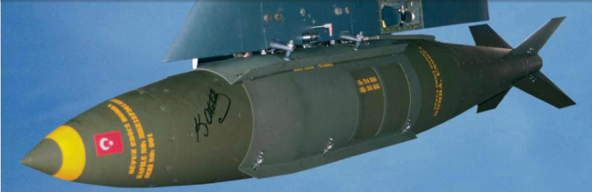

Figure 2.4 Penetrator Bomb (NEB)

## TOROS ARTILLERY ROCKET SYSTEM

The TOROS artillery rocket system (Topçu Roket Sistemi) consists of 230mm caliber rockets whose range is approximately 65km and 260mm caliber rockets whose range is approximately 110km. TOROS consist of five sub-systems that are launcher vehicle, logistic vehicle, maintenance vehicle, fire command-control vehicle and TOROS-230 and TOROS-260 ordnance.

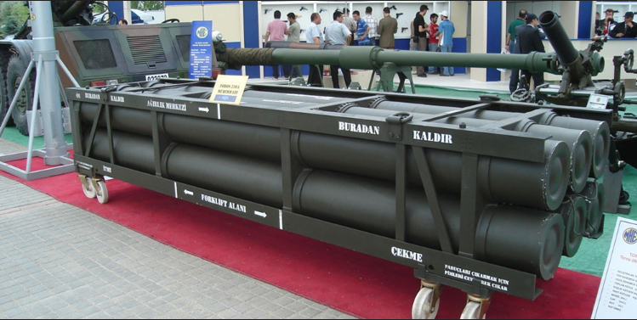

Figure 2.5 TOROS 230 ordnance

## THERMAL BATTERY

Thermal battery one of the most critical components of advanced missile system because thermal batteries are widely used as a main source for guidance tail kits, missiles, acoustic jammers etc. Therefore, Tubitak Sage has developed thermal battery technology by using completely thermal resources. Moreover, the institute has thermal battery design, production and testing capabilities. The institute has been designing and producing more than 10 thermal batteries that produced in accordance with the international military standards with different technical features so far. The batteries are also being exported t overseas markets since 2012. The institute continue to R&D studies to develop new thermal battery technologies.

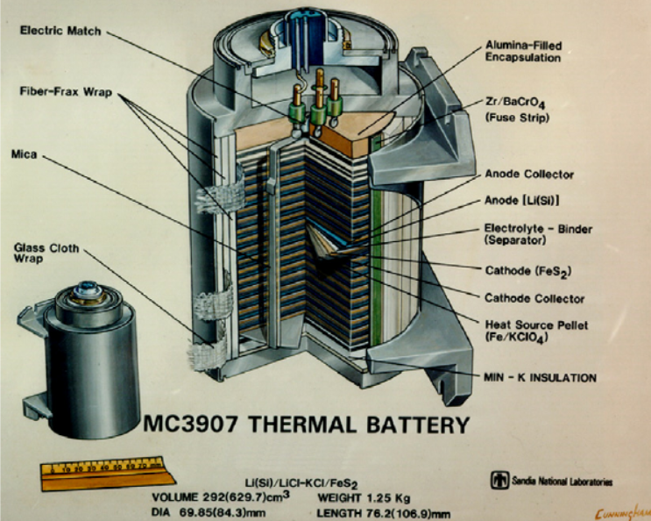

Figure 2.6 Thermal batteries

# INTRODUCTION

Besides theoretical information giving engineering course in school, summer practice give opportunity to observe engineering works and business life of an engineer, so summer practice very important for engineering student. Also, finding a company for summer practice give a chance in order to extend our network. Therefore, I decided to work with TUBITAK for summer practice because, TUBITAK is one of the most important engineering company in Turkey. As I mentioned before, TUBITAK’s research areas are too wide, so I choose TUBITAK SAGE for summer practice because I am closely interested in defense industry.

I worked with a field programming gate array that is known as FPGA and nios II processor that embedded on FPGA and Avalon bus architecture most of the summer practice period. Moreover, I tried to learn what is the universal asynchronous receiver and transmitter(UART) and how to write very high speed integrated circuit hardware description language(VHDL). Finally, I set a setup to observe works that are done during the internship.

# THE WORK CONDUCTED AT THE SUMMER PRACTICE

At the beginning of the internship, I learnt how to program field programming gate array with very high speed integrated circuit description language (VHDL). I am familiar with FPGA that manufactured by Altera company and Quartus software that is used to program FPGA that produced by Altera company from EE314 course, but I have never used VHDL before. Therefore, I studied to learn VHDL programming language during first week of my internship. Then, I started collecting information about nios II processor which is a configurable soft IP core. Nios II processor could be configured by using Q system tool that is located on Quartus software. Then, I tried to learn Avalon bus that is a bus structure. Signals which is necessary for Avalon and interface specifications for the bus structure were learned. In addition to this, I got information related to UART that is used to establish communication between host device and slave device.

Finally, after getting enough knowledge about nios II, Avalon bus structure and UART, Mr. Duman set a setup in order to apply what I learnt during summer practice. This setup used to communicate host computer and FPGA by sending UART signal and blinking led operation.

## 4.1 FIELD PROGRAMMING GATE ARRAY

Basically, FPGAs are silicon chips but the biggest difference between FPGA and other chips is FPGAs are reprogrammable chips. In other words, in classical non-hardware programmable integrations, user could not change connection between transistors. However, transistors located in FPGA are built independently of each other and freely generated. These transistors are connected each other with respect to function written by user in order to perform desired operations. A FPGA consists of logic cells, input/output blocks and interconnections. Logic cells that consist of lookup table(LUT), one D flip-flop and one 2*1 multiplexer are main components of FPGA’s structure. LUTs are a small memory that perform a logic operation like RAM. Massive and complex programs in FPGA is created by combining many logic cells depending on codes that can be written from Quartus for Altera’s FPGA and ISE for Xilinx’s FPGA.

Interfaces of the logic cells are provided with matrix-shaped data paths and programmable keys (according to the FPGA loaded program). FPGA design defines the connections between these logic cells by determining the function that each logic cell will perform and the state of the programmable switches (on / off)

In an FPGA %20 to %30 of all pins are specialized to perform a specific function. These pins are divided into three groups according to their function. The first group is power pins. Power pins group contains power and ground pins that are required for FPGA. The second group is configuration pins that are necessary to download created program to FPGA. The last group is clock pins. Clock pins supply a global clock signal to bank for synchronous design.

On the other hand, FPGA has also user pins that are configurable by users. There are three categories as input, output and input/output. Each i/o pin is connected to an IO cells that are supplied by VCCIO in the FPGA. Although the older FPGAs have more than one VCCIO pin, all the pins are supplied with the same voltage. However, in newly produced FPGAs, IOs can be divided into groups and these groups can be supplied from different voltages. Thus, when a group of IO pins operate at 3.3 V, the other group IO pins can operate with 2.5 volts.

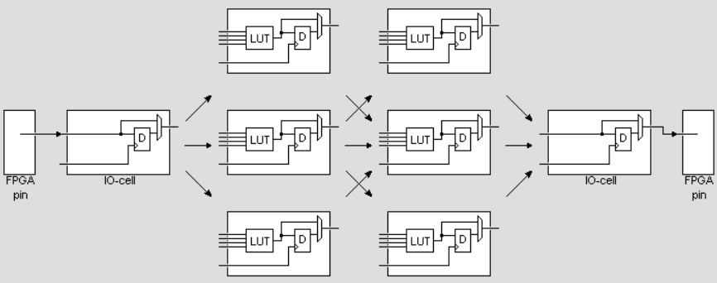

Figure 4.1.1 Logic cells, interconnections and IO cells in FPGA [66]

As I mentioned before, an FPGA is programmed by using ISE or Quartus software. In addition to this, users could use different hardware description language such as VHDL or Verilog that was used in lab course in order to program FPGA. In my summer practice, very high speed integrated circuit description language (VHDL) is used because VHDL is preferred to Verilog in defense industry applications. Therefore, I spent approximately four days in order to learn basic instruction of VHDL coding. Figure 4.1.1 and 4.1.2 shows some of my VHDL code studies. A function of the code that shown figure 4.1.1 is half adder. In the other code that shown figure 4.1.2 a full adder designed by using half adder code at the top level entity.

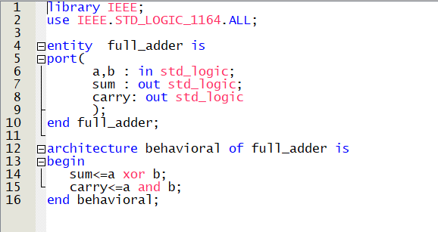

Figure 4.1.2 Half adder VHDL codes

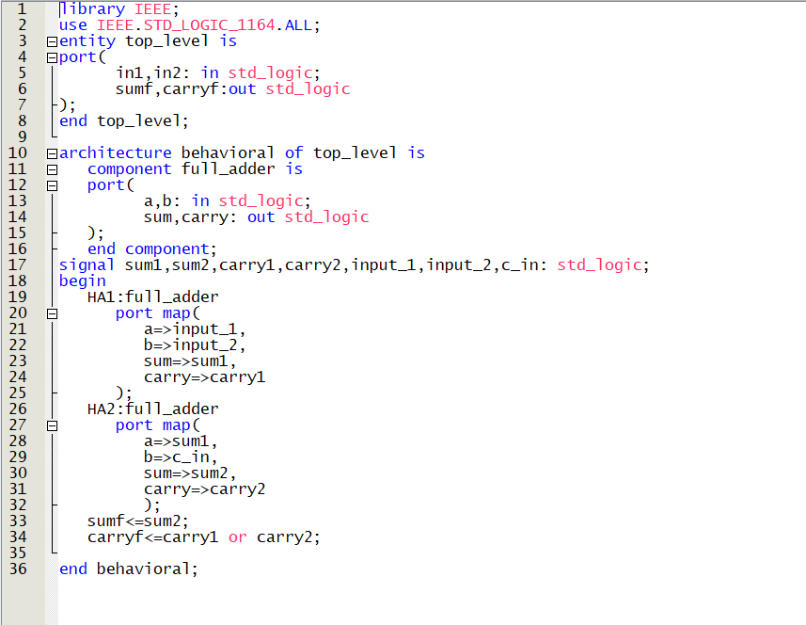

Figure 4.1.3 VHDL codes of top level design for full adder

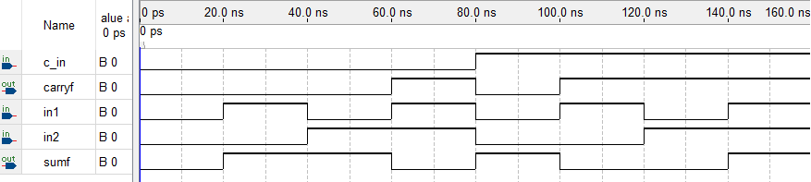

Figure 4.1.4 Simulation result of top level code

## 4.2 NIOS II PROCESSOR SYSTEM AND CORE

A Nios II processor system is similar to system on a chip or microcontroller because Nios II system consist of Nios II processor core which is similar to microprocessor, some peripherals such as UART, JTAG UART, parallel input output(PIO) etc. and memory on a single chip. Likewise, microcontroller, all type of Nios II processor systems use reliable instruction set and programming model. The main difference between microcontroller and Nios II system is that Nios II processor system is not fixed. A user could reconfigure the system in order to add or remove features and enhance performance of the Nios II processor system. Therefore, Nios II processor system that is provided by Altera FPGAs offer lower-cost design for customers. A sample Nios II processor system shown at figure 4.2.1 that drawn Microsoft Visio.

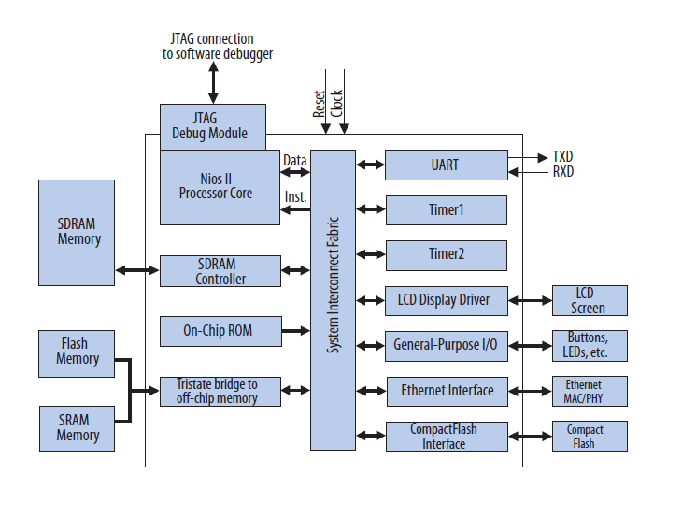

Figure 4.2.1 A sample Nios II processor system

Electronic cards of products of defense industry always contain different types of processor such as FPGA, microcontroller, digital signal processor(DSP) etc. Figure 4.2.2 is shown electronic card of stand off missile (SOM) that is produced by Tubitak SAGE. As seen figure 4.2.2, the electronic card contains both microprocessor and FPGA. Main component is FPGA in this card. On the other hand, microprocessor is used in order to establish communication between FPGA and host computer by helping of ADM3077E transceivers. In my summer practice, I was assigned to change this microprocessor with Nios II processor core. In this manner, the electronic card will be cheaper, and dimensions of the card will be smaller.

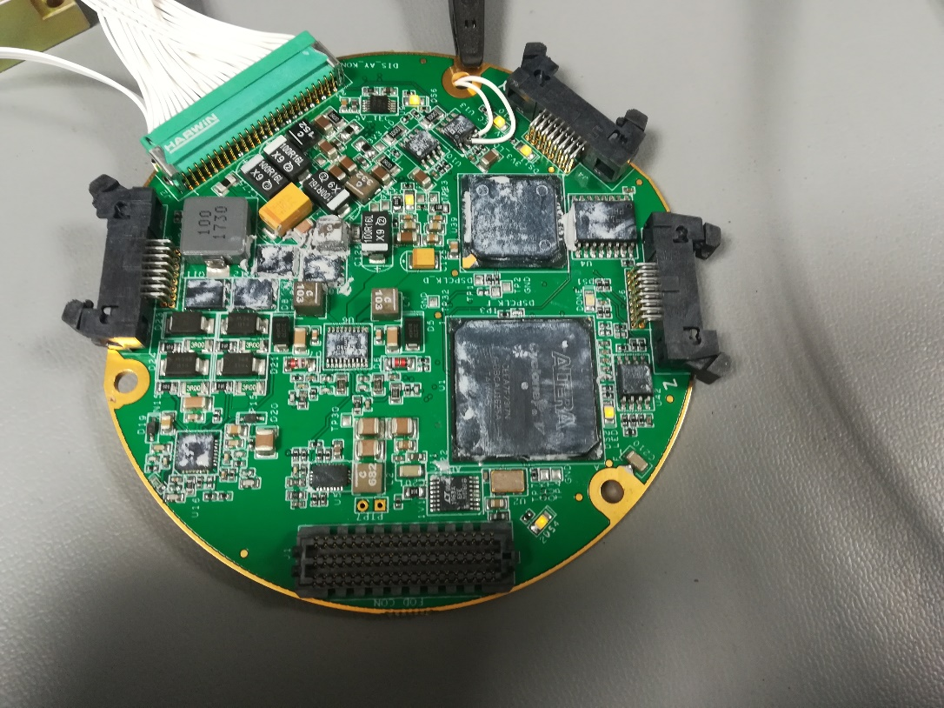

Figure 4.2.2 Printed circuit board (PCB) card of the Stand off Missile(SOM)

Nios II processor is a configurable soft IP core that means the processor core is not fixed in silicon and compatible with all FPGA produced Altera. Unlike classical microprocessor, user could add or remove feature on microprocessor in order to meet design goals. Moreover, Altera provides ready-made Nios II processor at Qsys that is one of the tools of Quartus software. Thus, user could not need to create a new Nios II processor configuration for every new design if ready-made processor meets design goals.

At this point I try to explain functions of functional units of the Nios II architecture. The functional unit of Nios II architecture that consist of data bus, memory protection unit(MPU) instruction and data cache memory etc. create the basis for the Nios II instruction set. However, the Nios II architecture describes an instruction set, not a hardware implementation. A functional unit can be implemented in hardware, emulated in software, or omitted entirely. I could explain functional units of Nios II architecture by using Nios II classical core on Qsys tool that shown in figure 4.2.3.

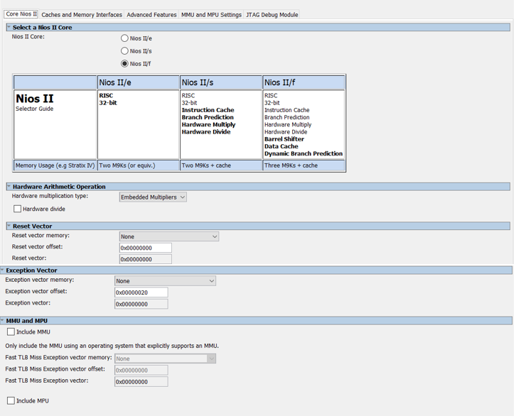

Figure 4.2.3 Nios II classical core on Qsys tool

There are three types of processor that are economy core, standard core and fast core. Both standard and fast cores are paid. Therefore, user who want to use economic and fast core should use licensed Quartus not the internet edition. However, economic core is free to use. Parameters in the reset vector title selects location of reset code on memory. Likewise reset vector, parameters in this section selects location of general exception vector. Both of exception vector and reset vector should be configured after placing memory component. Memory management unit (MMU) and memory protection unit (MMP) provide memory protection. I am going to discuss MMU and MPU in detail at MMU and MPU settings part.

Data and instruction caches are implemented in the memory blocks in the FPGA chip. As seen from figure 4.2.4 Nios II core includes instruction and data caches but economy version of core does not include both instruction cache and data cache. Although both standard and fast versions of core include instruction cache, data cache could be implemented only with fast version the core. Inclusion of caches improves performance of a Nios II system significantly. However, increasing amount of cache memory cause to decrease on chip memory resources. Therefore, data cache memory is generally provided by an external SDRAM chip for Altera FPGA

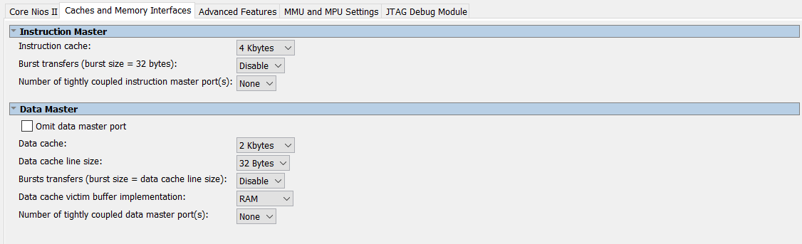

Figure 4.2.4 Caches and Memory interfaces of Nios II classical core

A user could not use both of memory management unit(MMU) and memory protection unit(MPU). Memory management unit(MMU) should be used with an operating system to be useful. There are two main function of memory management unit. One of them is virtual addressing that means translation of virtual addresses to physical address. A virtual address is used by software. On the other hand, a physical address is the address that the hardware outputs on the address lines of the Avalon bus. The other one is memory protection which means allowing access only to certain memory under certain condition. Moreover, memory management unit manage cache control and software process memory allocation. Unlike MMU, memory protection unit (MPU) is only used for memory protection. A user should not use memory protection unit if virtual memory management is necessary for operating system and runtime environments. Memory protection unit monitors all Nios II instruction fetches and data memory access to protect against errant software execution.

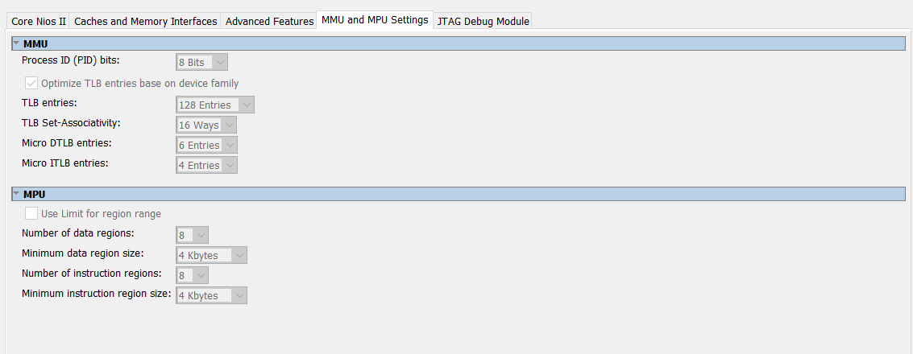

Figure 4.2.5 MMU and MPU Settings

The processor could be controlled remotely from a host PC by using JTAG debug module which supported by the Nios II architecture. PC based software debugging tools communicate with JTAG debug module and provide facilities such as downloading programs to memory, starting and stopping execution, setting breakpoints and watchpoints, analyzing registers and memory and collecting real time execution trace data.

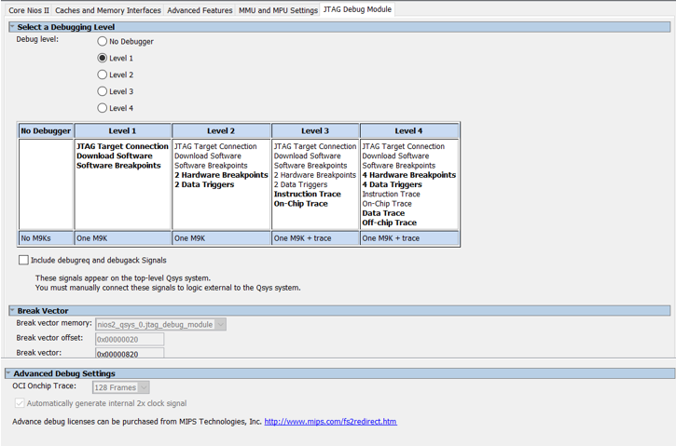

Figure 4.2.6 JTAG debug module

## 4.3 AVALON BUS STRUCTURE

Avalon bus is a simple bus structure that designed in order to connect Nios II processor with standard or custom peripherals by helping of system-on-a-programmable chip(SOPC). The main using purpose of Avalon interface is specifying the port connection between master and slave peripherals. In addition, when communications between components are established, Avalon interface specify the timing. Avalon bus provide an easy to understand protocol and conserving logic elements inside the field programming gate array. Moreover, Avalon bus provide synchronous operation by integrating well with other user logic that coexists on the same FPGA in order to avoid complex timing analysis issues.

Basic Avalon bus transactions transfer an 8-bit data, 16-bit data or 32-bit data between master and slave peripherals. After a transfer completes, the bus is immediately available on the next clock for another transaction that could be between same master-slave pair, or between unrelated masters and slaves. Avalon master and slave components communicate with each other depending on slave-side arbitration technique that determines which master components access to slave when multiple masters attempt to access the same slave at the same time. Thanks to slave side arbitration technique, Avalon bus supports multiple bus masters.

Avalon has been designed to connect peripherals by using system-on-a-programmable chip(SOPC) tool. Therefore, there are some principles of Avalon architecture. Components in the system should work with the same Avalon clock synchronously in order to avoid complexity. Also, synchronous timing analysis techniques is used to measure the performance of the Avalon bus and overall system. All signals are active low or high, that facilitates immediate turn-around of the bus. Multiplexer inside the Avalon bus determine which signals drive which component. Components are not required to tri-state their outputs, even when the peripheral is deselected. Thanks to using separate and dedicated ports to address, data and control signals, the design of component is simple. A peripheral does not need to decode address and data bus cycles and does not need to disable its outputs when it is not selected.

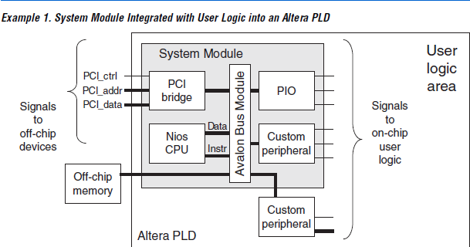

Figure 4.3.1 A basic example system

Figure 4.3.1 shows a simple system that contains components and Avalon bus module to establish communication between peripherals. A system must contain at least one master component in order to initiate transfer on the Avalon bus and entire Avalon bus module. In addition, master peripherals may have a slave port to receive data from other master peripherals on the Avalon bus. The system could contain several slave peripherals such as UARTs, timers or PIOs etc. Slave peripherals accept data transfer from the master port via Avalon bus module. Both of master port and slave port connects Avalon bus module directly that is main path for communication. Avalon bus module is generated automatically by the Qsys tool to connect bus and peripherals together.

|  |  |  |  |
| --- | --- | --- | --- |
| **Signal Type** | **Width** | **Direction** | **Description** |
| *clk* | 1 | in | The general clock signal. All bus transactions are synchronous to clk. |
| *address* | 1-32 | in | Address signal controlled by Avalon bus module. The signal determines which code block work in component |
| *read* | 1 | in | It is read enable signal. If read signal is high data read from the component by Avalon bus module |
| *readdata* | 1-32 | out | It holds reading data that read from Avalon bus when read signal is high |
| *write* | 1 | in | It is write enable signal. When the signal is high Avalon bus module write data to writedata register |
| *writedata* | 1-32 | in | It holds writing data |
| *chipselect* | 1 | in | Used only slave peripherals. Peripheral is inactive until chipselect signal |

Table 1: Description of Avalon bus necessary signal

The main signals of the Avalon bus structure are shown in table 1. These signals are necessary to establish communication between peripherals. Therefore, every peripheral that can be custom or standard in Qsys tool should have Avalon interface. Read signal and chipselect should be asserted in order to read data from slave peripheral. If peripheral has not an output signal read and readdata signal are unnecessary. Likewise read operation, chipselect and write signal should be asserted to perform write operation. Transferred data is written to writedata signal by the Avalon bus. Figure 4.3.2 and figure 4.3.3 show block schematic and timing diagrams of write and read operation.

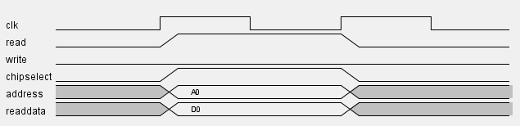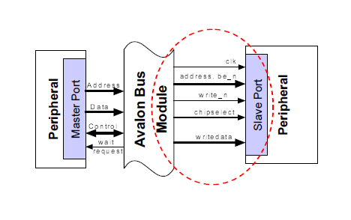

Figure 4.3.2 Read transfer timing diagram and block schematic

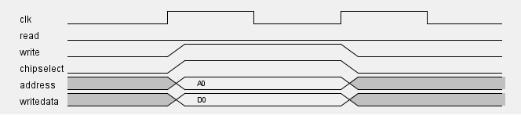

Figure 4.3.3 Write transfer timing diagram and block schematic

## 4.4 SOPC BUILDER (Qsys tool)

SOPC builder software used to automates the task of integrating hardware components such as Nios II processor, on chip memory, UART etc. Although components integrated manually by writing HDL modules in traditional design methods, components interconnected easily by using graphical user interface of SOPC builder and HDL files which define all components of the system are created by the program automatically. SOPC builder could generate Verilog HDL files or VHDL files depending on user.

Altera provide wide range of ready-to-use SOPC components that include microprocessors such as Nios II processor, microcontroller peripherals such as a Scatter-Gather DMA Controller and timer, serial communication interfaces such as UART and serial peripheral interface(SPI), general purpose I/O, communications peripherals such as a 10/ 100/ 1000 Ethernet MAC and interfaces to off-chip devices. In addition, a component could be created if provided component does not meet design requirements. In my summer practice, I generated a component for my blinking led project. In spite of using PIO component for the project, I wrote VHDL code that shown at figure 4.4.1 in order to understand creating custom component in Qsys tool and Avalon bus structure.

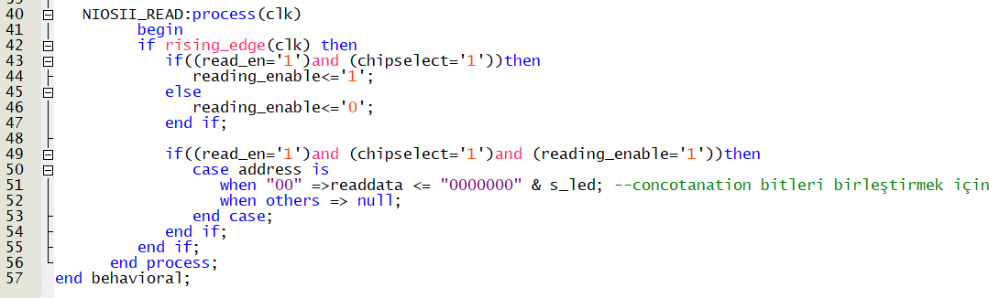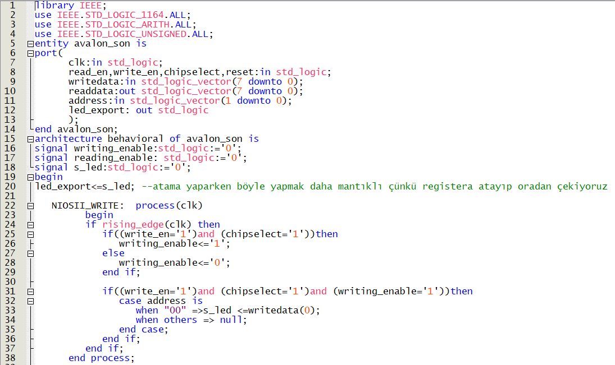

Figure 4.4.1 VHDL code of the component

As seen from figure 4.4.1 there are many signals such as clk, read_en, writedata etc. Except for led_export signal, all signal added for Avalon bus structure that establish communication between components because components that created should include Avalon bus signal in order to communicate other components such as on chip memory. After writing code of desired component, Qsys tool should be used in order to add component to the system. Then we click on the new component button at the right side of the Qsys’s screen and we select VHDL code file to add. After adding VHDL file, type of the signals that used at the VHDL file and Avalon interfaces should be determined. Avalon Memory-Mapped interface (Avalon MM) is used in my design because Avalon MM interface is an address based read/write interface that is typical of master-slave connection. Moreover, Avalon clock interface and Avalon reset interface are used for clock and reset signal respectively. Interface of the led_export signal was selected Avalon conduit interface and it is exported because the signal make connection external to the Qsys system. Figure 4.4.3 show type, block diagram and parameters of led_export signal

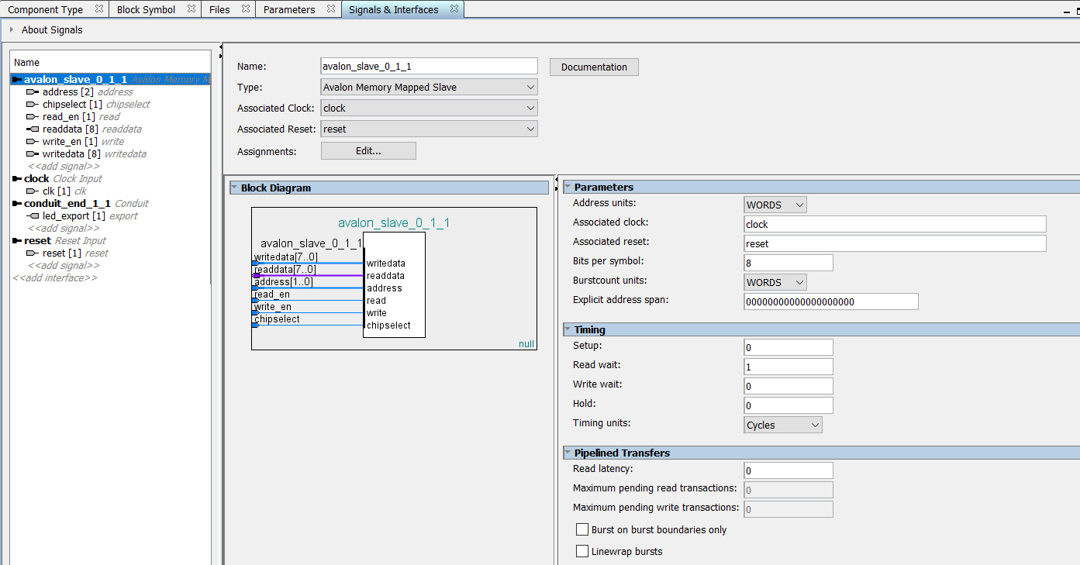

Figure 4.4.2 Signal and interface

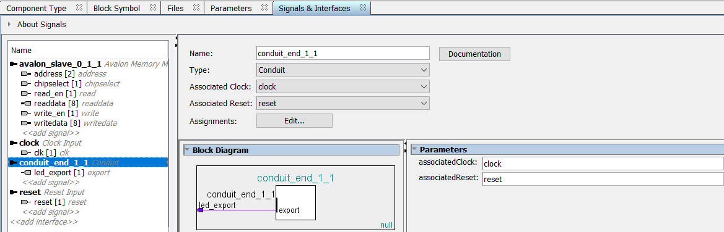

Figure 4.4.3 Signal and interface

with learning basic instruction of programmable logic controller which known as PLC. PLC is always used for automation system. There are some similarities between microprocessor and PLC but PLC is preferred for automation system because it is more durable, reliable and portable than microprocessors. PLC provides easier solution for complex automation system and using of PLC is easier than microprocessors because you do not write any code, so you do not have to learn any software language. Although there are many different types of PLC thanks to many companies that produce PLC, PLC devices generally consist of inputs, outputs and central process unit which decides outputs with respect to status of inputs. Despite variety of PLC, I used Siemens Simatic S7-1200 1214C DC/DC/DC in my summer practice. There is a computer program whose name is TIA Portal v13 to write PLC codes on computer to load PLC. It is Siemens automation program and I used this program to control

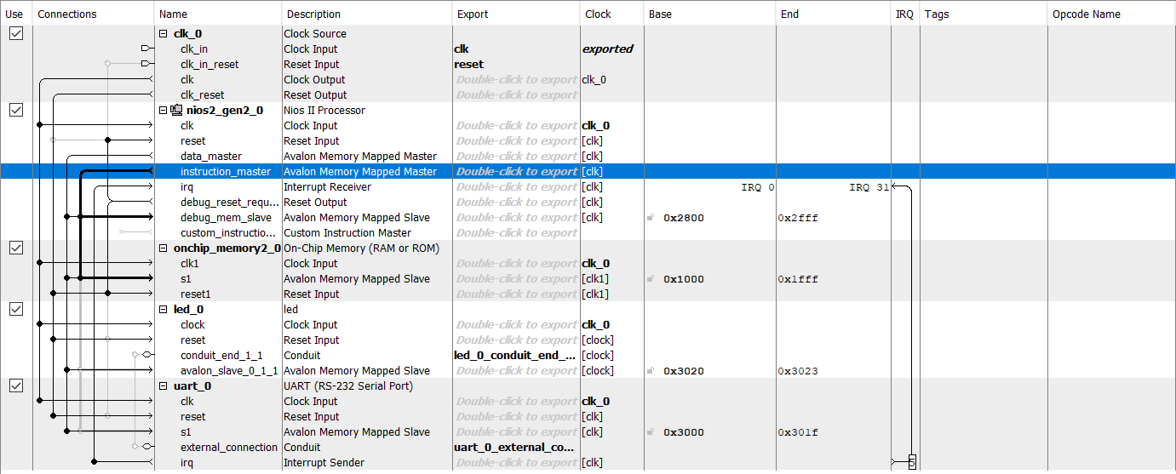

Figure 4.2.1: Basic PLC Setup

In Figure 4.2.1 shows basic PLC setup that was set by Mr. Bildirici. I worked with this setup along my summer practice. In addition to PLC, there is a circuit breaker, ac to dc converter and a plc starter kit in figure 4.2.1. This setup was supplied by line to neutral voltage which is 220V AC. However, we need 24V dc voltage in order to work with plc without any damage so we use AC DC converter in order to get 24V DC voltage. This setup also includes circuit breaker in order to protect PLC from high current. The last thing in this figure is starter kit. Thanks to starter kit, I could close or open input voltages easily by using switches of starter kit. When a switch is open, an input that controlled by the switch has 24V. On the other hand, when switch is close an input that controlled by the switch has 0V. [7]

After setting up setup, I loaded TIA Portal v13 software on computer in order to programmed PLC. Tıa Portal v13 software includes many options which are basic instruction, advanced instruction, technologies and communication to solve automation problems in industries. I spent approximately four days in order to learn basic instruction that includes bit logic, timer, counter, comparator, move, conversion operations and math operations. Then, I try to apply these basic instructions by generating square wave signal with 50% duty cycle and period of the wave is two seconds. Figure 4.2.2 show program that generate the square wave.

If one-time input 1 is closed, upper branch will be active and dummy_1 is set as true (1) whose first value is equal to false (0) without any operation after one second because of Ton timer operation. Then, below relay on first branch will be active and dummy_1 will be false (0) because of (R), after one second because of Ton timer operation. In other words, a variable which named dummy_1 whose value is held in PLC memory is changed periodically. Therefore, output_1 blink periodically because of dummy_1 relay on below branch. The relay is open for one second and close for one second continuously. In this program, timers are adjusted for one second, so period of generating square wave is two seconds.

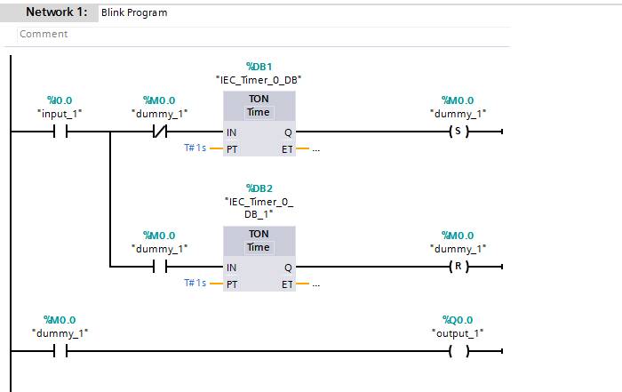

Figure 4.2.2: Square Wave Generator with 50% Duty Cycle

## 4.3 TEMPARATURE SENSOR

At the beginning of the second week of my summer practice, I set up temperature sensor setup with helping of my supervisor Mr. Bildirici. I used PT 100 and SİEMENS SM 1231RTD module for temperature measurement setup. Figure 4.3.1 shows PT100 sensor and SİEMENS SM 1231RTD module. Now I am going to give some information about module and PT 100. First of all, I want to mention about PT 100. PT 100 is one of the most used temperature sensor because it is cheap, useful, capable and effective to directly interface with PLC. Pt 100 temperature sensor consist of platinum as sensing material, so it is named as PT 100. The resistance value of platinum changes linearly with respect to change of temperature. For example, resistance value of platinum is 100Ω when temperature is 0°C and resistance value is equal to 109.73 Ω when temperature is 25°C. Therefore, it can be used to identify the temperature by comparing the resistance value and temperature-resistance variation log value that is provided by manufacturer. On the other hand, Siemens SM 1231RTD module enable to measure temperature with high precision by using temperature sensor such as PT 100, PT 200, Ni 100, Cu 10. [8]

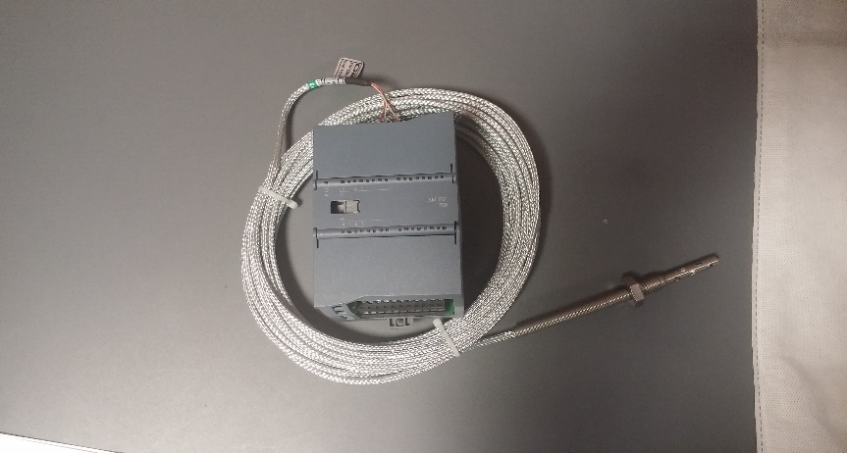

Figure 4.3.1

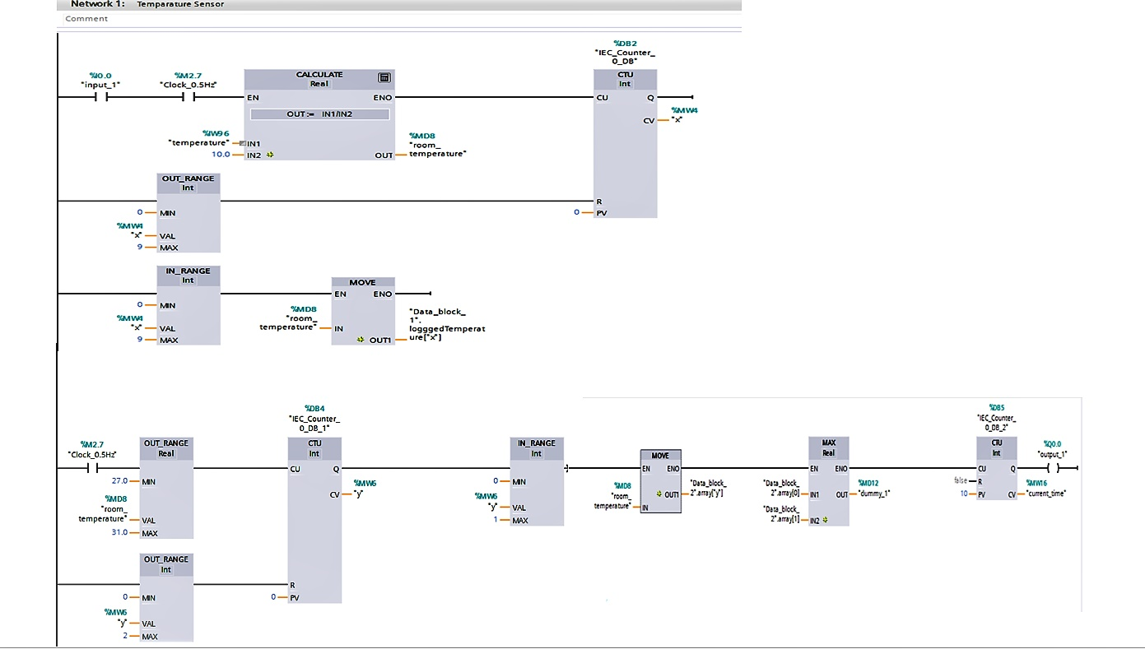Now I will give information about program that showed in Figure 4.3.2. Firstly, I measured room temperature with periodical intervals in order to achieve this I used clock that set up from PLC configuration. Then, I created array that named as logged temperature and last measured ten temperature values is held at this array (second branch in the figure is continuation of first branch in order to fit into the figure I show it on the second branch). Then, I programmed warning system if room temperature is not between 27 °C and 31°C. When room temperature is below 27°C or upper 31°C another array will be active. After that, the program compares last measured two temperatures and the biggest one is saved on PLC memory as dummy_1. Finally, if last measured ten temperatures is not between 27°C and 31°C output_1 will be active for a second and output_1’s light will open on PLC

Figure 4.3.2. Temperature sensor application

## 4.4 COMMUNICATION BETWEEN ENERGY ANALYZER and PLC

First of all, energy analyzer is the most useful device in order to measure line to neutral voltage, line to line voltage, currents, frequency, reactive power, real power, apparent power, power factor etc. easily. In my summer practice, I got opportunity to work with energy analyzer that is Siemens Senton Pac 4200 which shown in figure 4.4.1. If someone wants to retrieve data from energy analyzer such as voltage, current or frequency etc. s/he should establish communication between PLC and energy analyzer. Also, s/he needs a computer in order to read data from computer display. Therefore, I used ethernet switch to complete communication along computer, PLC and energy analyzer by using ethernet cable.

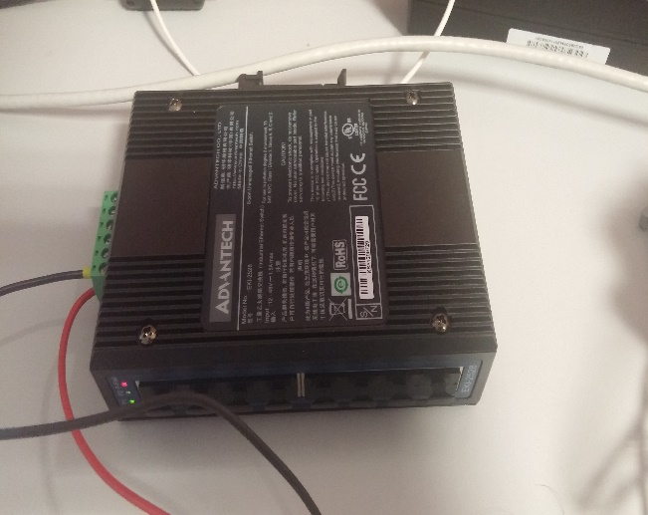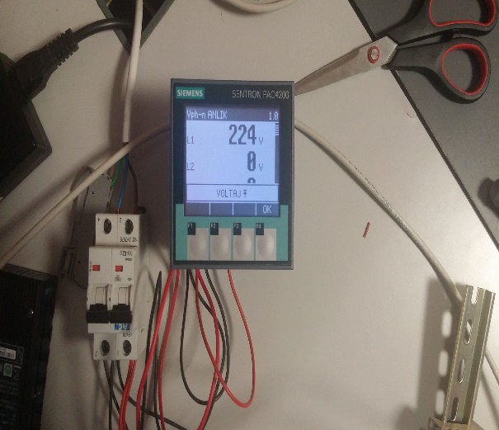

Figure 4.4.1 Energy Analyzer Figure 4.4.2 Ethernet Switch

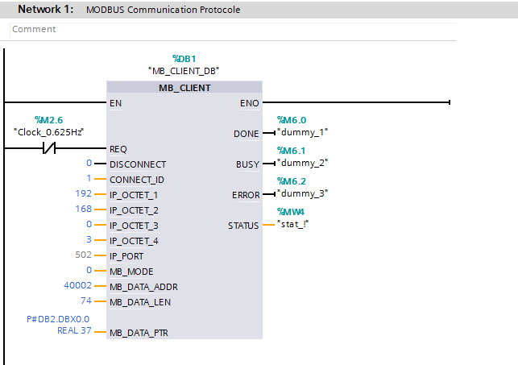

Figure 4.4.3 Communication with energy analyzer

Some protocols are used in order to establish communication between different devices. For instance, open system interconnection (OSI) protocol that have seven different layers is used for network system to [standardize](http://tureng.com/tr/turkce-ingilizce/standardize) software and hardware that used for communication system. On the other hand, TCP/IP (Transmission Control Protocol/ Internet Protocol) always use to found communication between two hosts that can be different or same network. In my summer practice, I used Modbus protocol that is serial communication protocol and used to transmit information between electric devices by using serial lines. Modbus protocol is free protocol. In other words, manufacturers could this protocol without any payment, so Modbus protocol is preferred by many manufacturers throughout many industries. Therefore, I used Modbus protocol to establish communication between PLC and Energy Analyzer. With helping of MB_CLIENT block, PLC connected energy analyzer by using IP of energy analyzer that is 192.168.0.3 for this setup. After connected energy analyzer, PLC retrieved data from analyzer and store them in data_block2 as 4 bits data, because data type of data block 2 is real.



Figure 4.4.4 Retrieved data from analyzer

Figure 4.4.4 shows energy data such as voltage, current, apparent, active and reactive power that are reading from energy analyzer by PLC. These data are ordered with respect to manual of energy analyzer. If someone wants to know other data like power factors, frequency etc. s/he should extend MB_DATA_LEN that shown on figure 4.4.3. In other words, if someone wants total power factor that is ninetieth order in manual of Siemens Pac 4200, MB_DATA_LEN should be at least 180 in order to read total power factor on the screen of TIA Portal v13 program. As a result, voltage, current, power factor etc. can be read easily by establish communication along computer, PLC and energy analyzer via a ethernet switch and ethernet cables. [9]

## 4.5 DRIVING INDUCTION MOTOR

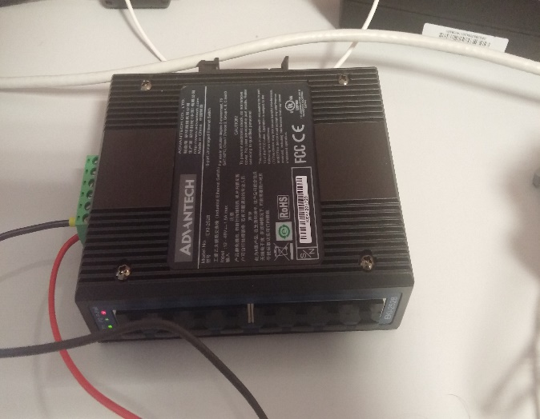 In my summer practice, I also engaged in induction motor and motor driver that is shown in Figure 4.5.1. This setup consists of two main part induction motor and motor driver. The induction motor which shown in figure is 0.37 kW, three phases, max 950 revolutions per unit (these data retrieved from manual sheet of the motor) Siemens Induction Motor. On the other hand, motor driver is Siemens G110 motor driver whose using purpose is converting signal. First signal that comes the driver is one phase line to neutral voltage and this single-phase voltage is converted DC voltage by the driver. Then, the driver again converts the DC signal to three phase AC signal and send these three-phase signal to induction motor with helping of wires. [10] Except for induction motor and motor driver, this setup contains gear wheel and two inductive sensors. One sensor count bulge on gear wheel the other one count hollow on the wheel. With helping of inductive sensor, frequency of the wheel was calculated easily. [11]

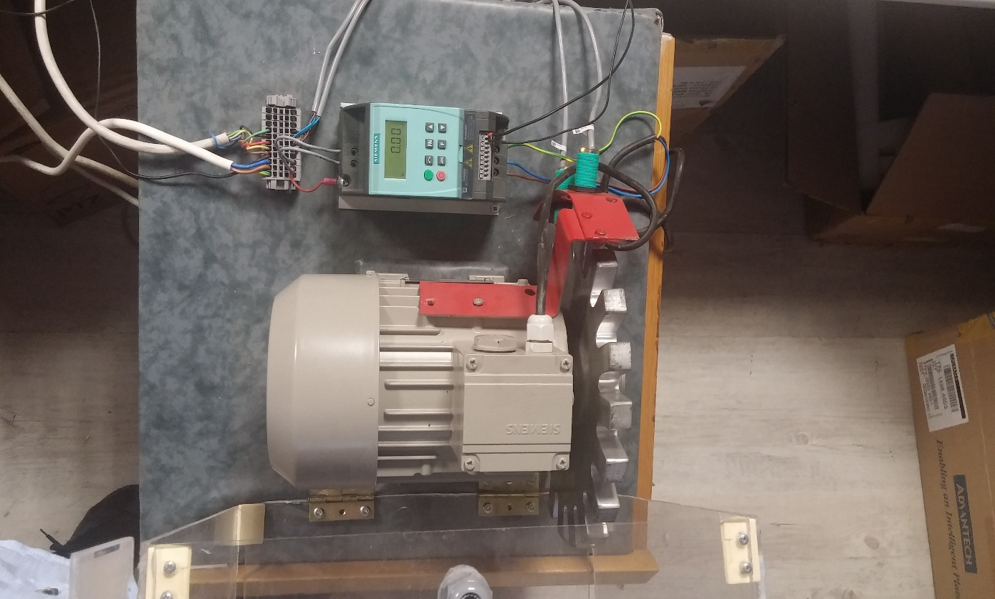

Figure 4.5.1 Driving Induction Motor Setup

First, I drove the motor via the motor driver. I changed rotating frequency of gear wheel by using arrows on the driver. Then, I controlled frequency of the wheel by using potentiometer. For this purpose, potentiometer was connected 8, 9, 10 numbered inputs of the motor driver because these inputs used for manual control of the induction motor. After controlling the induction motor via the motor driver and potentiometer, I learned using high-speed counter that is one of the properties of PLC because I used high speed counter to control frequency value of the induction motor, so I connected outputs of the inductive sensor to inputs of PLC. Actually, PLC has counter in its basic instructions. However, if an event occurs faster than the organization block execution rate which works in every 40 milliseconds, I should use high speed counter. High speed counter can count an event faster than the cyclic organization block execution rate. In other words, high speed counter (HSC) gives more accurate data at high frequencies. Figure 4.5.2 show HSC properties on PLC.



Figure 4.5.2 Properties of HSC

Generally, I worked on organization block of PLC but I worked on cyclic interrupt block in order to read frequency value of the induction motor because it is work in every 10 milliseconds. Then, we write a program that is shown Figure 4.5.3 to calculate frequency of the motor. As I said before gear had 20 gear bulge and motors revolution was 950 revolutions per minute which was approximately 1/3 of 3000(50 Hz that is frequency of grid voltage). As a result of this, to match frequencies in driver and PLC program, I divided with 20 and multiplied with 3 result of high speed counter which is sensor_1 in Figure 4.5.3. I observed that the frequencies which was on driver screen and PLC program was approximately equal. Also, I compared data which came from sensor_1 and sensor_2 and I observed the data are same so, this program was working well.

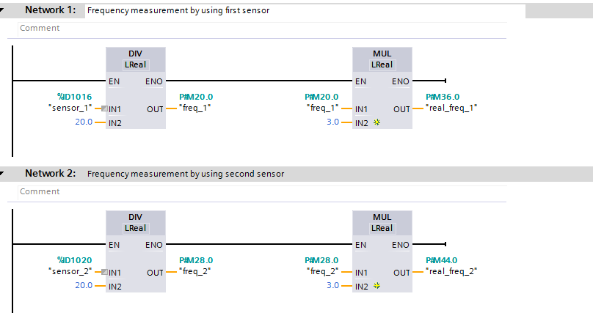

Figure 4.5.3 Frequency measurement

## 4.6 PID CONTROL VIA THE PLC

As I mentioned before, PLC has a lot of important properties. One of them is PID (Proportional Integral Derivative) control. I have no idea about PID control because I could not take feedback course. In my summer practice, I get opportunity to learn PID control with helping of Mr. Bildirici. Also, I am lucky for applying PID control to control frequency of the induction motor. There is a PID block in technology options of TIA portal v13. I added PID control block which shown figure 4.6.1 on cyclic interrupt block. I should three areas on PID block such as input, setpoint, output pwm. Input is calculated frequencies that shown in figure 4.5.3. Setpoint is frequency which I wanted and output pwm is output that send the induction motor.

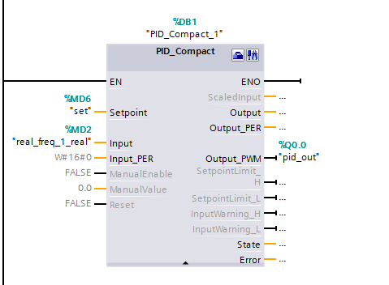

Figure 4.6.1 PID Compact Block

In order to control the induction motor, I needed different voltage value whose range is 0 to 10V but PLC I worked with has no analog outputs. However, output of PID block is PWM signal with different duty cycle so I used low-pass filter that shown in figure 4.6.2 in order to get analog output. Moreover, peak value of generating PWM signal of PLC is 24 V but the voltage sent to the motor driver should be in 0-10V range. In order not to damage the motor driver I also set up voltage divider circuit which shown in figure 4.6.

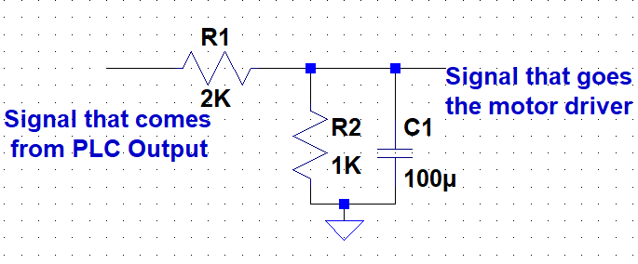

Figure 4.6.2 Low Pass Filter and Voltage Divider

After producing analog output via low pass filter, I started to control the induction motor with helping of PLC. However, I should tune PID parameters that shown in figure 4.6.3 in order to control the motor perfectly. For this purpose, I changed PID parameters especially proportional gain (Kp) and integration time (Ki) in order to observe reaction of the motor. Then, I decided right parameter to control the motor. Moreover, I constructed main block shown in figure 4.6.4. I changed setpoint value by using these blocks and using starter kit. Then, I observed effect of proportional gain (Kp) and integration time (Ki) on PI control. I did not use derivative action time because using derivative action time increase noise on the motor.

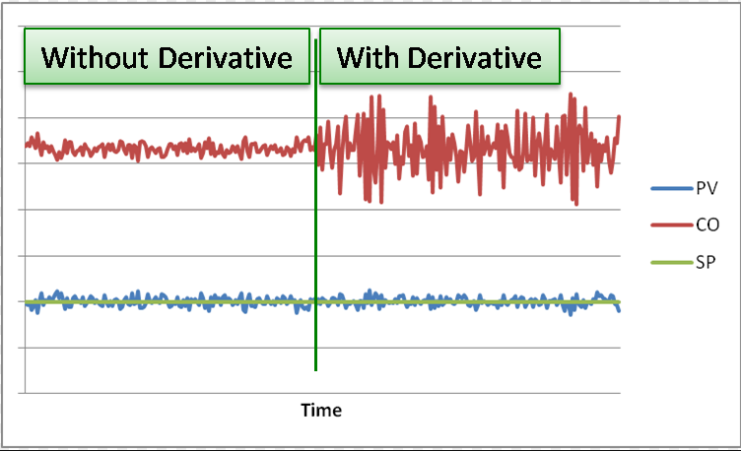Figure 4.6.2 Effect of derivative action time on PID control [12]

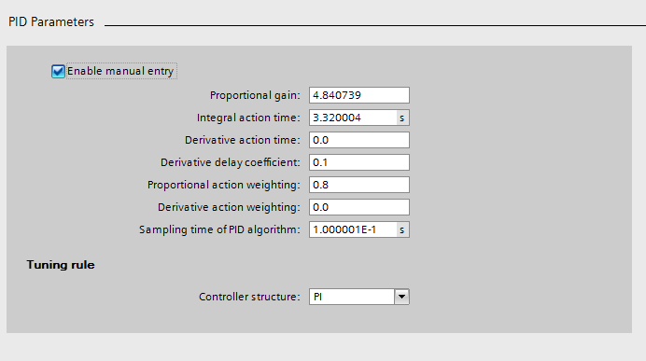

Figure 4.6.3 PID parameters

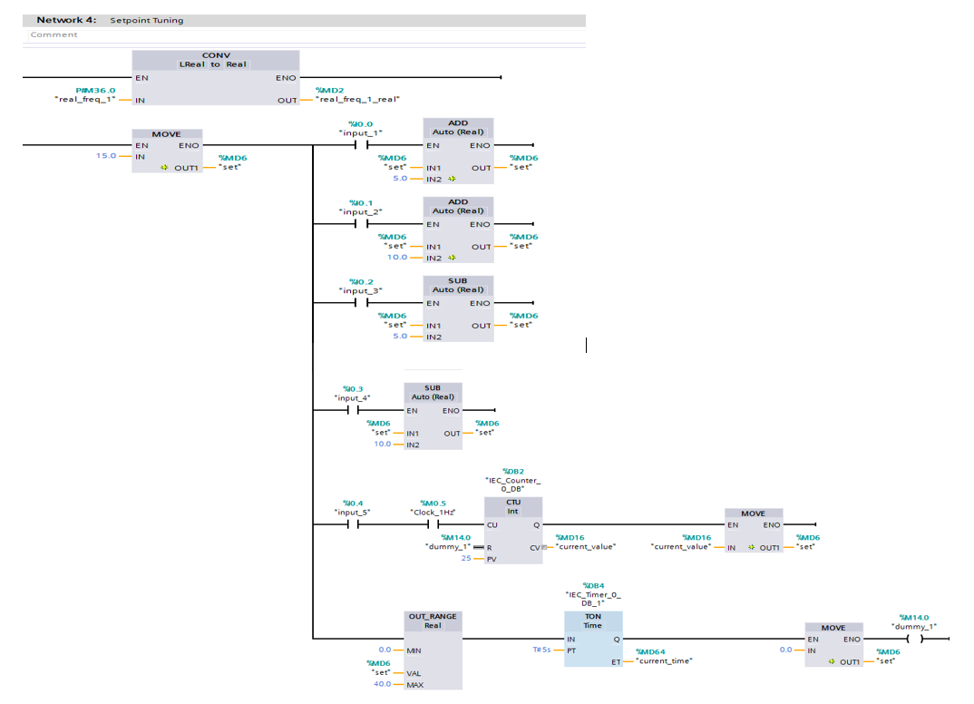

Figure 4.6.4 Setpoint tuning

There is a PID control parameter tuning function on PLC. Thanks to this function, PID parameters is tuned automatically. First of all, I used this function and control the induction motor properly. Figure 4.6.5 shows PID parameters that tuned automatically and figure 4.6.6 shows setpoint and reaction of the motor frequency.



Figure 4.6.5 PID Parameters

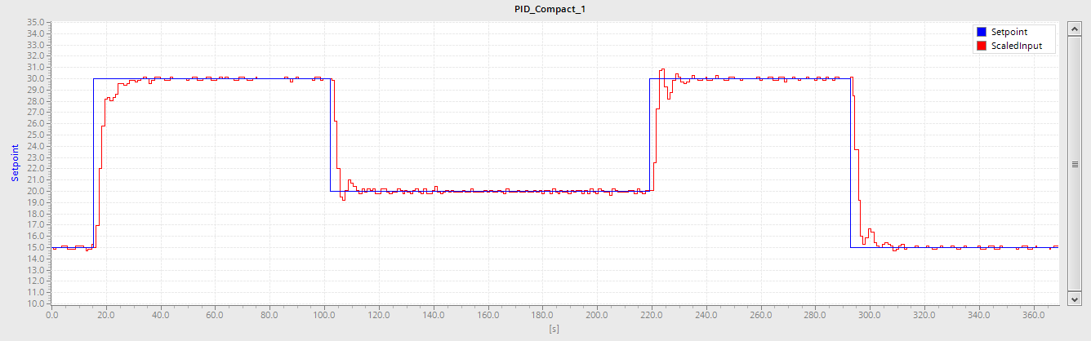

Figure 4.6.6 Relation between setpoint and motor frequency

Figure 4.6.6 shows us settling time that is passing time until scaled input is equal to setpoint value. The settling time is equal to ≈17 seconds. Also, there is no oscillation on this graph. Therefore, I could evaluate these parameters as proper paramaters for PI control.

Then, I changed proportional gain(Kp) and integral action time (Ki) in order to understand effect of these parameters on PI control. When I changed proportional gain from 4.84 to 9.0 the system started to oscillate. Figure 4.6.7 shows the parameters and figure 4.6.8 shows setpoint and scaled input. As a result of this graph, the system can be said in under damped.

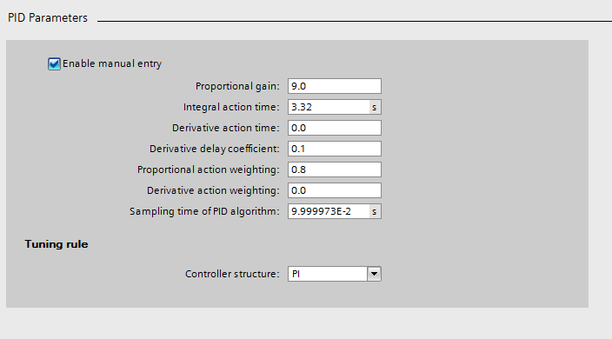

Figure 4.6.7 PI parameters

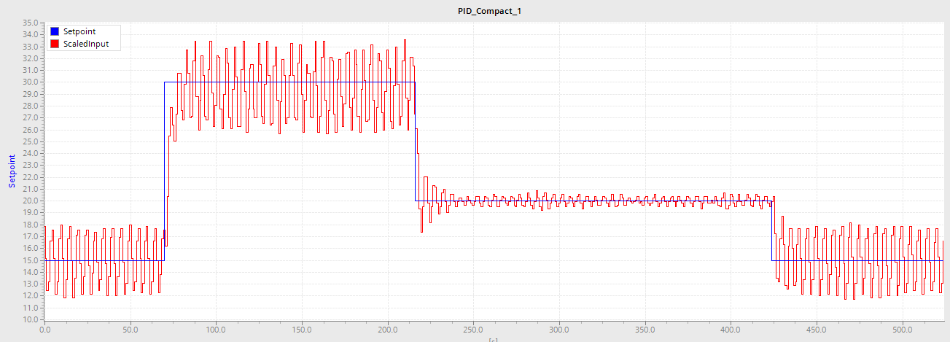

Figure 4.6.8 Setpoint and Scaled Input

Then, I changed proportional gain from 4.84 to 2.0 and settling time got longer. Figure 4.6.9 shows the parameters and figure 4.6.10 shows setpoint and scaled input. As a result of this graph, the system can be said in over damped.

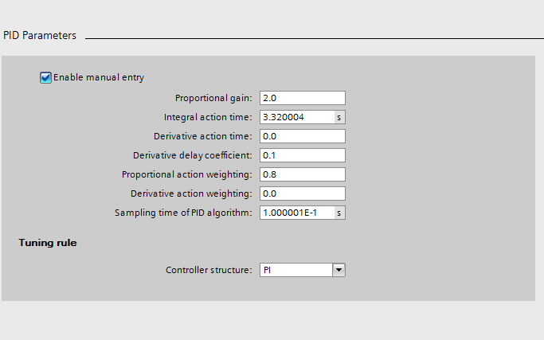

Figure 4.6.9 PI parameters

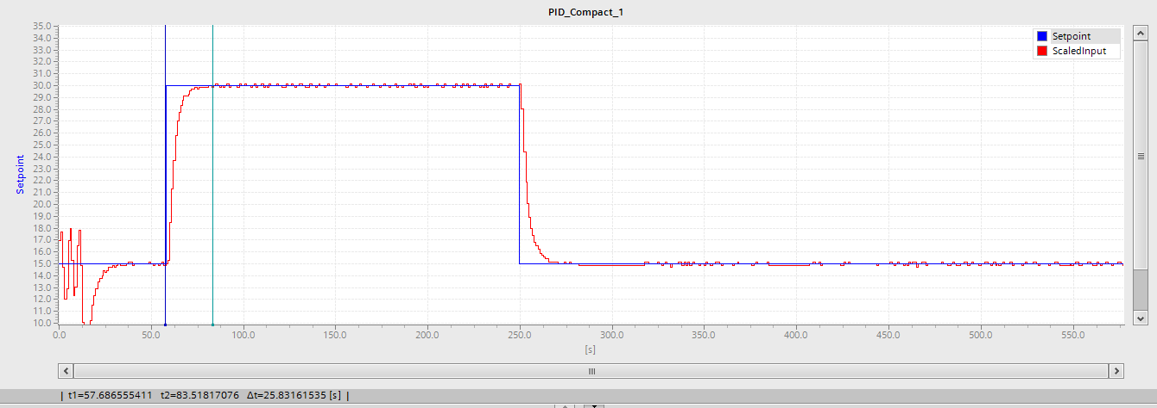

Figure 4.6.10 Setpoint and Scaled Input

After examinig figure 4.6.6, 4.6.8 and 4.6.10, I have some idea about function of proportional gain (Kp). Incresing proportional gain(Kp) reduces steady state error but after certain limit increasing proportional gain(Kp) causes overshoot and oscillation. Moreover, increasing Kp decreases rise time. Settling time is 17 seconds in figure 4.6.6 but settling time is 25.8 seconds in figure 4.6.10

Then, I started to change integral action timein order to understand function of integral action time (Ki). When I changed integral action time from 3.32 to 1.0 the sysrem started to oscillate. Figure 4.6.11 shows the parameters and figure 4.6.12 shows setpoint and scaled input. As a result of this graph, the system can be said in under damped.

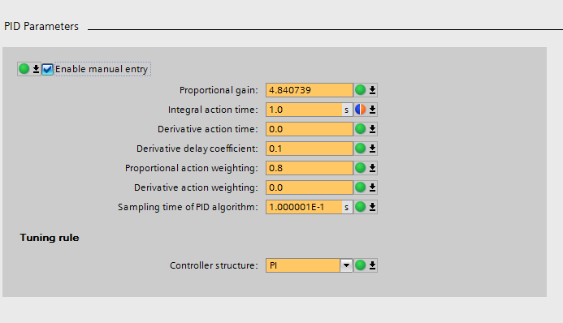

Figure 4.6.11 PI parameters

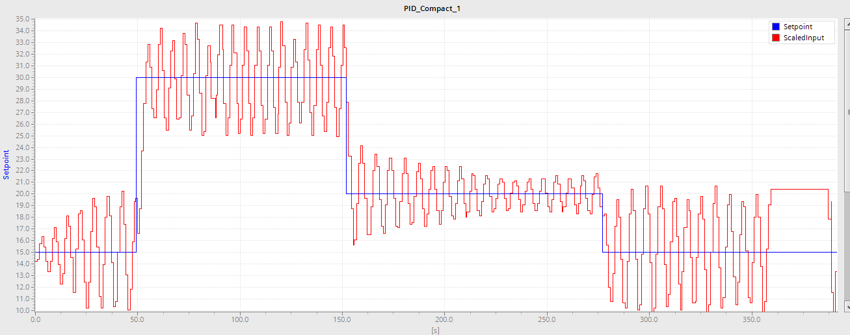

Figure 4.6.12 Setpoint and Scaled Input

Then, I changed integral action time from 3.32 to 5.5 and settling time got longer. Figure 4.6.13 shows the parameters and figure 4.6.14 shows setpoint and scaled input. As a result of this graph, the system can be said in over damped.

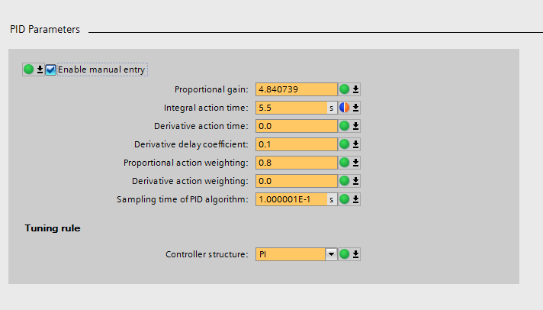

Figure 4.6.13 PI parameters

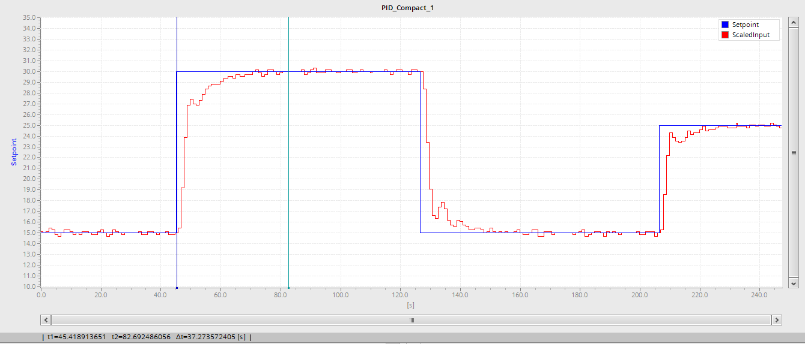

Figure 4.6.14 Setpoint and Scaled Input

As a result of figure 4.6.6, 4.6.12 and 4.6.14, integral action time is important to get rid of small differences between setpoint and scaled input. In other words, invreasing integral action time decreases steady state error. Also, decreasing integration time(Ki) decrease rise time but low integration time(Ki) causes oscillation and overshoot.

As a consequence of these result, I tried to find new proportional gain (Kp) and new integral action time (Ki) without using auto tuning property of PLC. I changed integral action time as 2.5 seconds because I know I should choose small value for integral action time in order to quick response but too small value causes oscillation. I changed proportional gain as 2.0 because too big value causes oscillation. As a result of these parameters, I got the graph that is shown in figure 4.6.15. There is no overshoot and oscillation in the graph and settling time is 21 seconds. Therefore, these parameter could be evaluated as proper parameters for PI control.

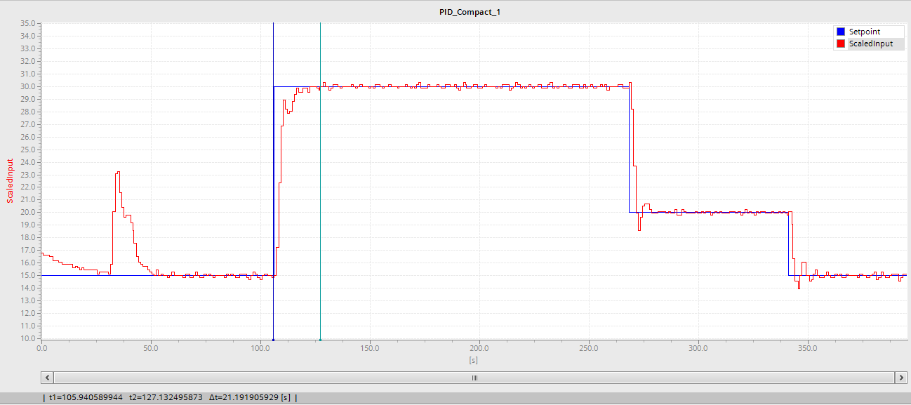

Figure 4.6.15 Setpoint and Scaled Input

## 4.7 SINGLE PHASE SCHEMATIC

First of all, I want to mention what is the single-phase schematic. Single phase schematic could be named as a riser diagram because the single-phase schematic covers the whole line from the place where energy is produced to in the place where energy is consumed. Using purpose of single phase schematic is getting information about electricity plan of a place. Thanks to a single-phase schematic, a person can understand electric plan of a place easily. Every circuit component should be shown on single phase schematic and the properties of these components should be indicated on the schematic in order to make it easier to understand. As we know, electricity is produced in three phases at the power plant. However, only one phase is shown in single phase diagram in order to prevent complication. Therefore, anyone can understand the diagram easily.

Now, I am going to explain basic component of single phase diagram. The first component is disconnectors. Disconnectors are switching devices that can open and close the circuit while the circuit is unloaded in medium and high voltage systems and form a clearance visible in the open position. The second is high voltage circuit breaker. They are used to provide current by cutting off or closing current by opening at idle, overload and short-circuit. Especially at high voltage, opening circuit get harder and it can cause serious damage so high voltage circuit breaker is used to open circuit. Opening or closing of high voltage circuit breaker could be done manually or automatically. The other component is busbar. An electrical busbar is defined as a conductor or a group of conductors used for collecting electrical energy from the incoming feeders and distributes them to the outgoing feeders. In other words, an electrical busbar collects the electrical energy at one location. After learning these information, I tried to draw a single-phase schematic which shown in figure 4.7.1.

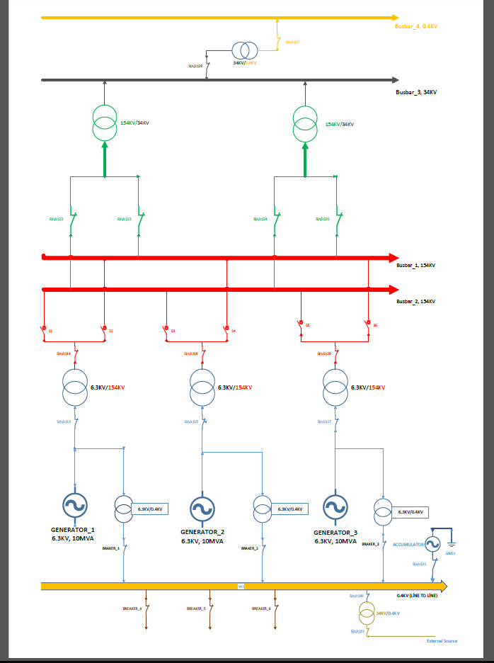

Figure 4.7.1 Single Phase Schematic

# CONCLUSION

After drawing single phase schematic, I have completed my summer practice. In this period, I gained a lot of experience about electrical and electronics engineers’ practical works and work life. I mainly worked on three areas that are power electronics, control theory and power system. First of all, I tried to understand how does hydroelectrical power plant work. Then, I engaged with programmable logic controller that is known as PLC. PLC is generally use in automation system. I learnt basic instruction of PLC such as bit logic, timer, counter, comparator, move operations and math functions. PLC has a lot of features such as Modbus communication, PID control block, PWM generator, high speed counter etc. I am glad to get opportunity to apply these features in my setup. In addition, I got information about specifications of the data types and using TIA Portal v13 program that is used to control PLC.

Except for PLC, I received an opportunity to observe and practice with energy analyzer, ethernet switch, inductive sensor, induction motor and induction motor driver. I did some research about working principle of the induction motors which is one of the topic of the electromechanical energy conversion courses that is third year course. Moreover, I controlled frequency of the induction motor by doing PID control that is also one of the topic of third year course that is feedback system. In addition, I searched about AC to DC and DC to 3phase AC converters which is the one of the topic of a fourth-year course which is under power electronic option. Because of these, I got a chance in order to practice not only my background information, but also get information about important engineering applications that I will learn in the future during my summer practice

In addition, I found a chance to learn single phase schematic. Single phase schematic is used to get information about electric plan of a place because single phase schematic shows the whole line from a place where electricity is produced to another place where electricity is consumed. Thanks to Mr. Bildirici, I draw a basic single-phase schematic at the end of the summer practice.

Finally, I am very pleased that ı did my summer practice in TUBITAK MRC. Thanks to Mr. Bildirici, I learnt a lot of things about PLC, company and work life. In addition, TUBITAK MRC is one of the most prestigious company in Turkey so the company submitted many opportunities such as PLC that is not cheap or induction motor in order to improve my engineering skills. Besides improving engineering skills, I got a chance to get information about what engineers do in real life in the summer practice. For me it was a very good feeling to be a part of a company like TÜBİTAK MRC so I strongly recommend this company for electrical and electronics students who are interested in power electronics, power systems and control areas.

# REFERENCES

[1] <http://mam.tubitak.gov.tr/en/kurumsal/who-we-are-0>

[2] <http://ee.mam.tubitak.gov.tr/en/about-ei/who-we-are>

[3] <http://mam.tubitak.gov.tr/en/kurumsal/organizational-chart>

[4] <http://ee.mam.tubitak.gov.tr/en/about-ei/personnel-profile>

[5] <http://ee.mam.tubitak.gov.tr/en>

[6] <http://www.mpoweruk.com/hydro_power.htm>

[7] Manual of the Siemens S7-1200 PLC [https://cache.industry.siemens.com/dl/files/465/36932465/att_106119/v1/s71200_s ystem_manual_en-US_en-US.pdf](https://cache.industry.siemens.com/dl/files/465/36932465/att_106119/v1/s71200_s%20ystem_manual_en-US_en-US.pdf)

[8] <http://eblogbd.com/what-is-pt-100-definition-and-principle>

[9] Manual of the Siemens Sentron PAC3200 [http://www.siemens.fi/pool/products/industry/iadt_is/tuotteet/pienjannitekojeet/k ytkenta_suojaus_ja_ohjaus/verkkoanalysaattori/sentron-pac3200-manuaali- englanti.pdf](http://www.siemens.fi/pool/products/industry/iadt_is/tuotteet/pienjannitekojeet/k%20ytkenta_suojaus_ja_ohjaus/verkkoanalysaattori/sentron-pac3200-manuaali-%20englanti.pdf)

[10] Manual of the Siemens Sinamics G110 <http://www.logosfoundation.org/instrum_gwr/harmo/Datasheets/Sinamics_G110.pdf>

[11] Manual of the Pepperl-Fuchs Sensor <http://files.pepperl-fuchs.com/selector_files/navi/productInfo/edb/084463_eng.pdf>

[12] <http://blog.opticontrols.com/archives/153>

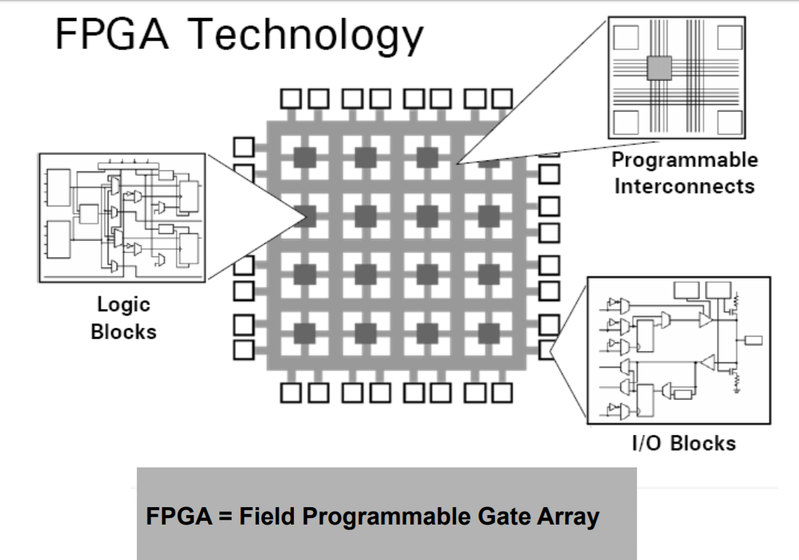

https://www.uio.no/studier/emner/matnat/fys/FYS3240/v16/lecture-notes/l10---digital-elecronics-and-embedded-systems.pdf